Docker Install:

#This document is a instruction about how to install docker and WordPress websites via #docker in ubuntu system.

**#The word like this are commands I used.**

#The sentence start with # is the description and comment.

**sudo apt update**

**sudo apt upgrade**

#type Y when it ask you to confirm

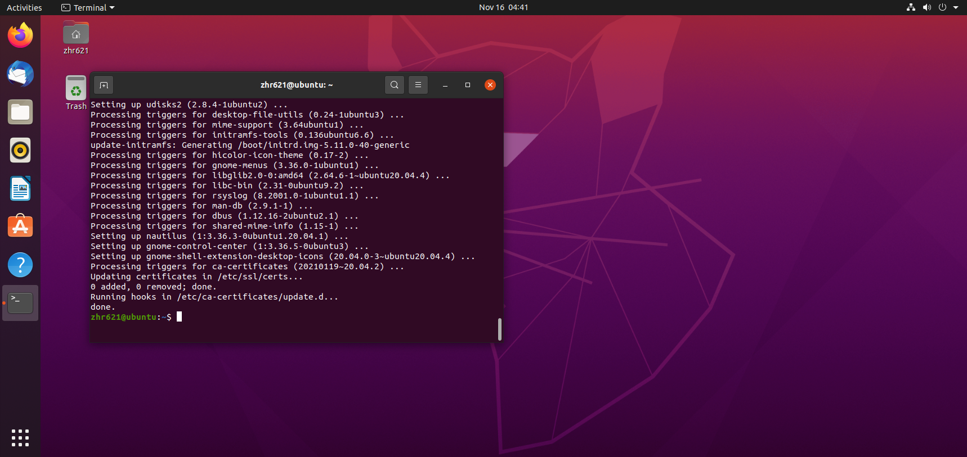

**sudo apt install docker.io**

#type Y when it ask you to confirm

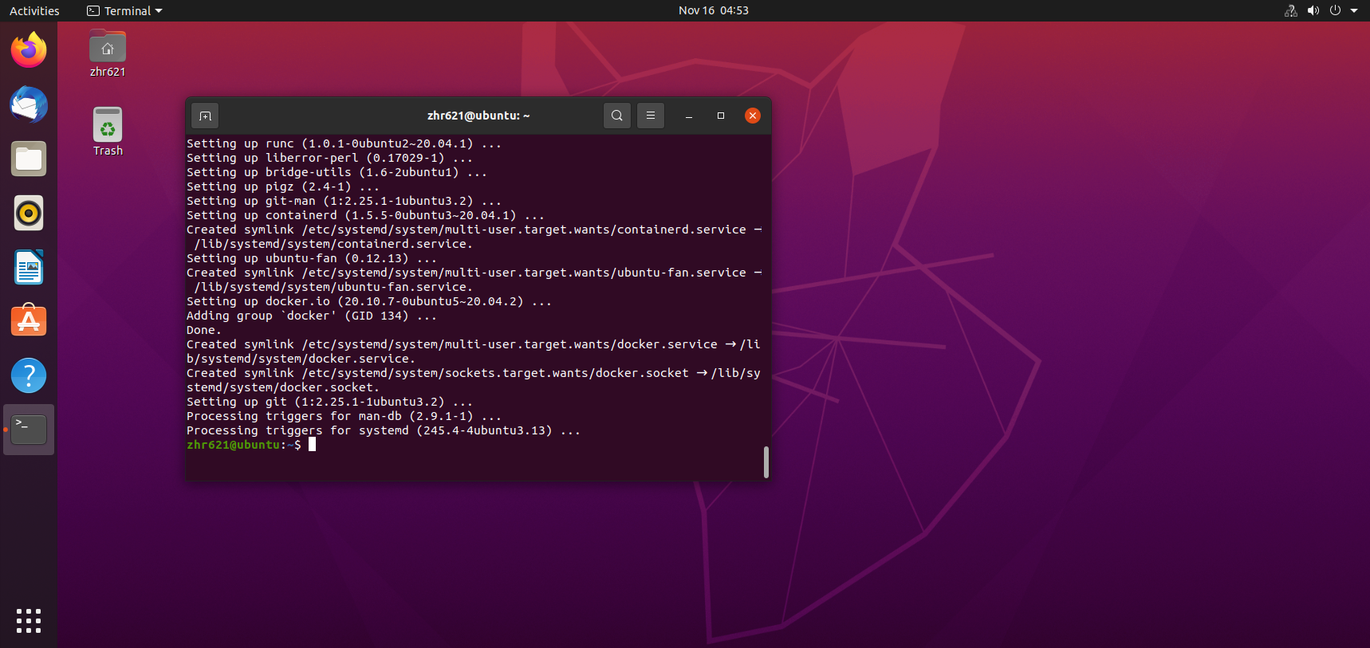

**sudo service docker status**

**#**this command check whether the docker is running, if it is inactive use “sudo service docker start” to start it.

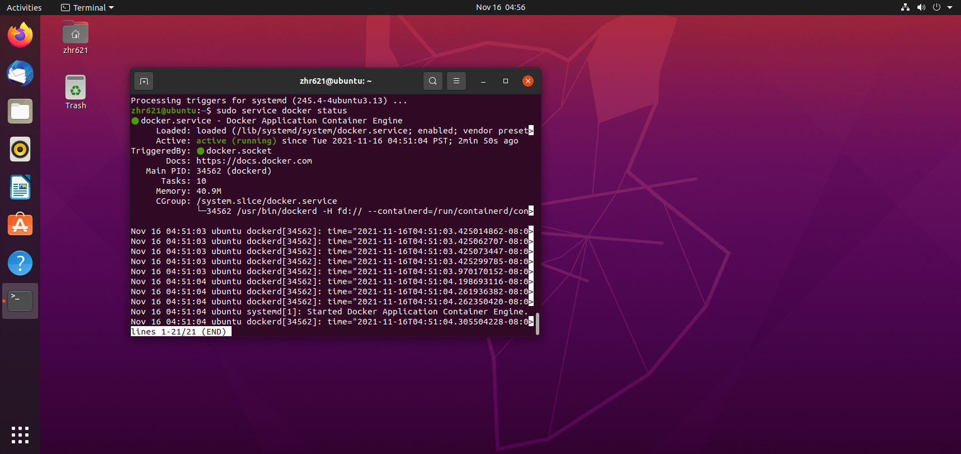

**sudo apt install curl**

#install command curl

**sudo curl -L "https://github.com/docker/compose/releases/download/1.29.2/docker-compose-$(uname -s)-$(uname -m)" -o /usr/local/bin/docker-compose**

**#**this command download the docker-compose file from url “https://github.com/.........etc” and download it to our local directory. (/usr/local/bin/)

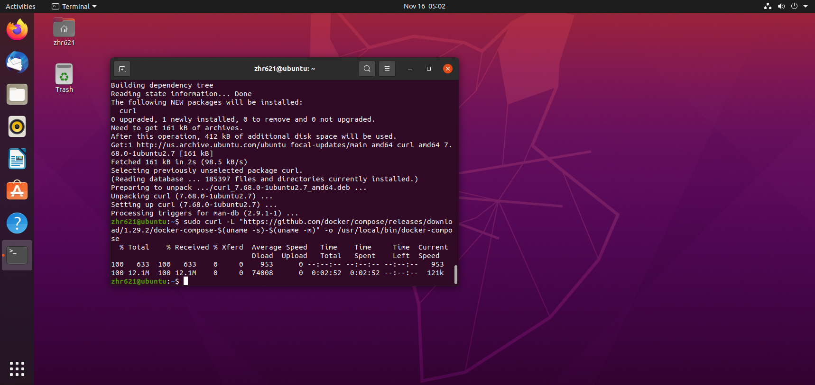

**sudo chmod +x /usr/local/bin/docker-compose**

#add the execute permission to the file we just download.

**docker compose –version**

**#**this command is used to check if the docker compose is installed successfully.

After install the docker and compose, we can go to next step which WordPress install

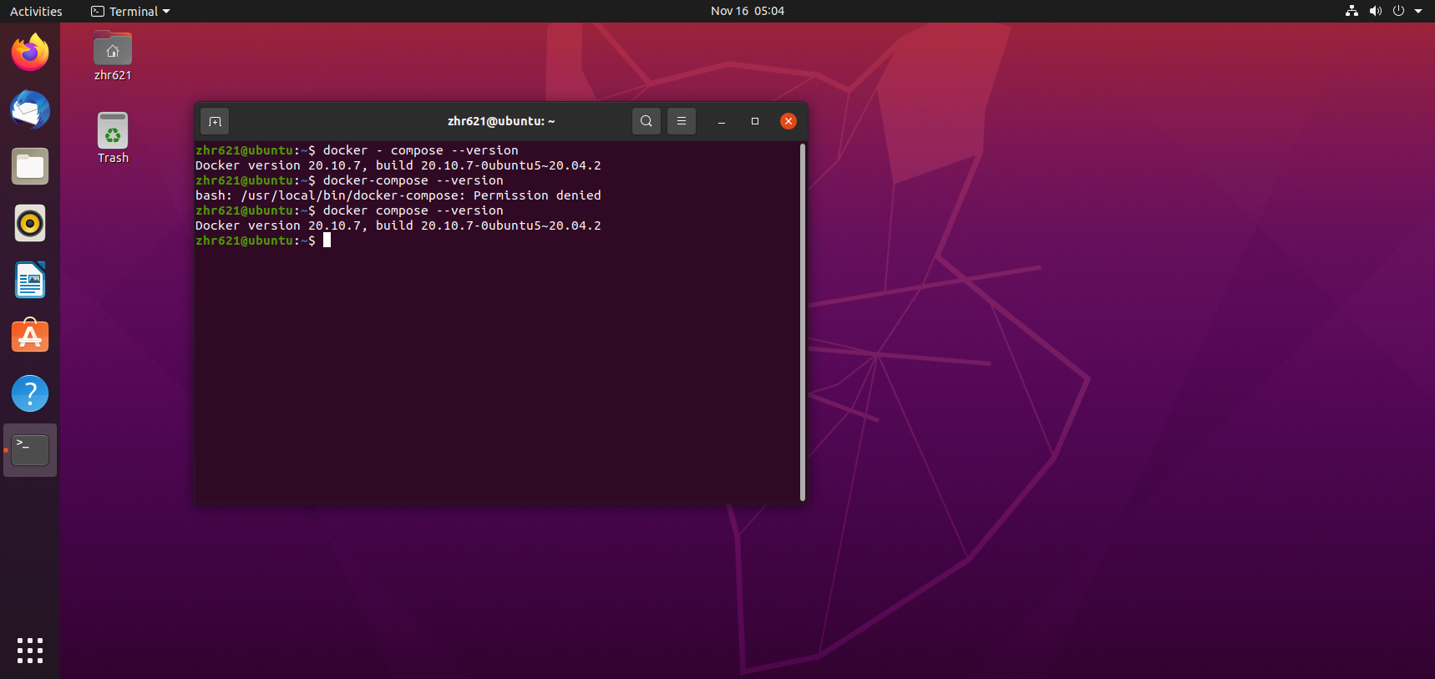

WordPress install:

**cd**

**#** first of all , I like make project in user’s home directory. You can choose whatever directory you like.

**sudo mkdir word_press**

# make a empty directory for project

**cd word_press**

**#**go to this folder

**sudo vi docker-compose.yml**

**#**create the file named “docker-compose.yml”

#Copy below code to the docker-compose.yml.

version: "3.9"

services:

db:

image: mysql:5.7

volumes:

- db_data:/var/lib/mysql

restart: always

environment:

MYSQL_ROOT_PASSWORD: somewordpress

MYSQL_DATABASE: wordpress

MYSQL_USER: wordpress

MYSQL_PASSWORD: wordpress

wordpress:

depends_on:

- db

image: wordpress:latest

volumes:

- wordpress_data:/var/www/html

ports:

- "8000:80"

restart: always

environment:

WORDPRESS_DB_HOST: db:3306

WORDPRESS_DB_USER: wordpress

WORDPRESS_DB_PASSWORD: wordpress

WORDPRESS_DB_NAME: wordpress

volumes:

db_data: {}

wordpress_data: {}

#this file contain 2 service. First one is DB(database) and second one is WordPress.

1. Image: means the image used for the service, for example. Db use mysql:5.7and WordPress use the newest WordPress version.
2. Volumes: means mount this service to a directory. Allowing you to modify the code on the fly, without having to rebuild the image
3. Restart: always means always restart.
4. Environment: means set the environment variable.(user, password, rootpassword etc…)
5. Depends_on: in WordPress service means the order of service to start. WordPress depends on db.so the db. should start first because WordPress depends on it.
6. Ports means the port to visit this service, for example I use my “Ip address:8000” to visit my WordPress website

**sudo docker-compose up -d**

#when you see the below notification, you are good to go, wait for several minutes then go #to the browser.

#“Status: Downloaded newer image for wordpress:latest

#Creating my_wordpress_db_1 ... done

#Creating my_wordpress_wordpress_1 ... done”

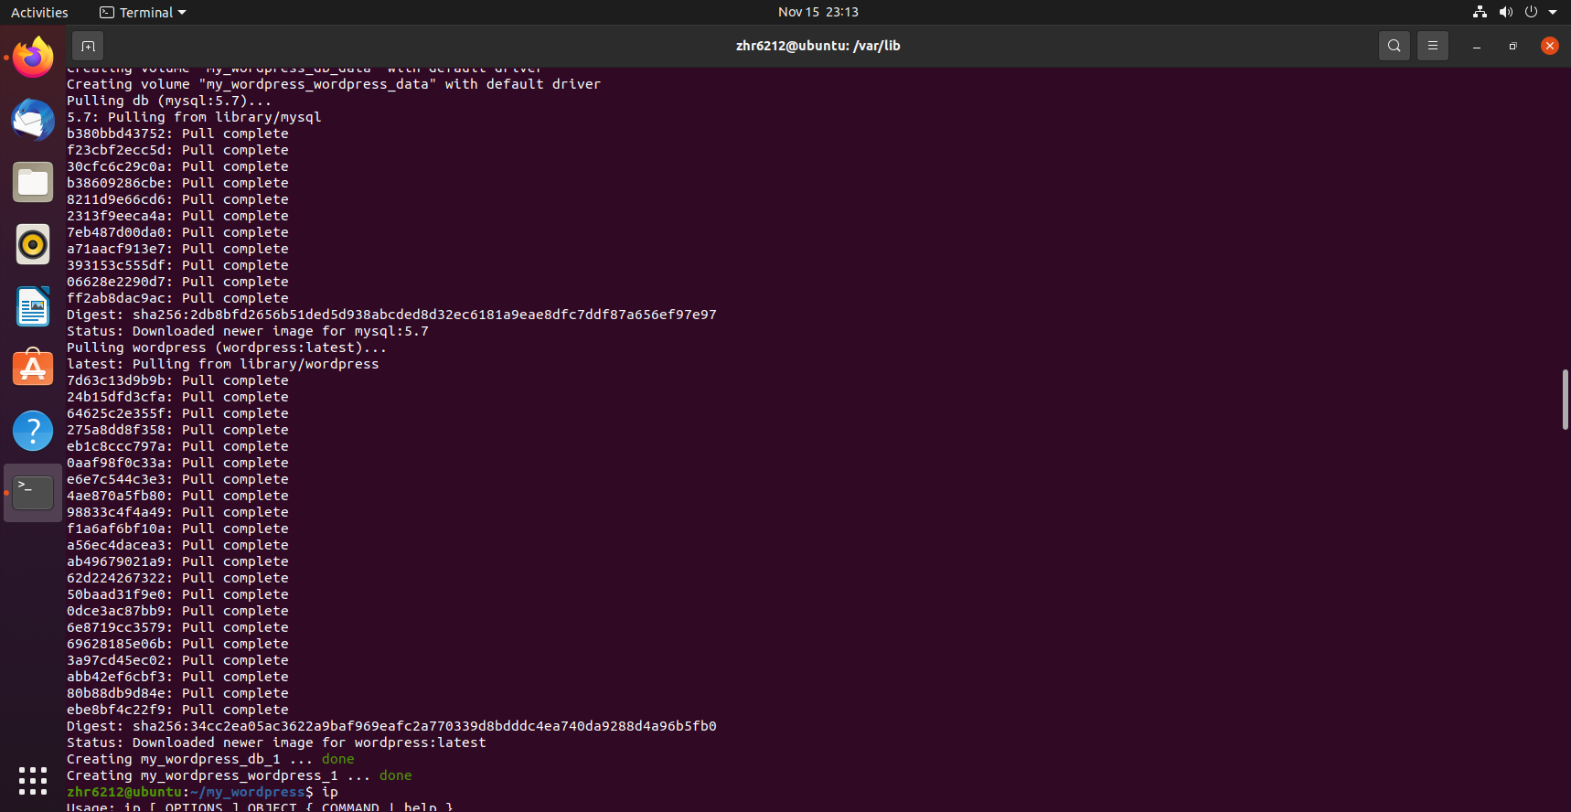

#Use ip address:port to visit your wordpress website. The default port is 8000. Select a language and fill your information about your account.

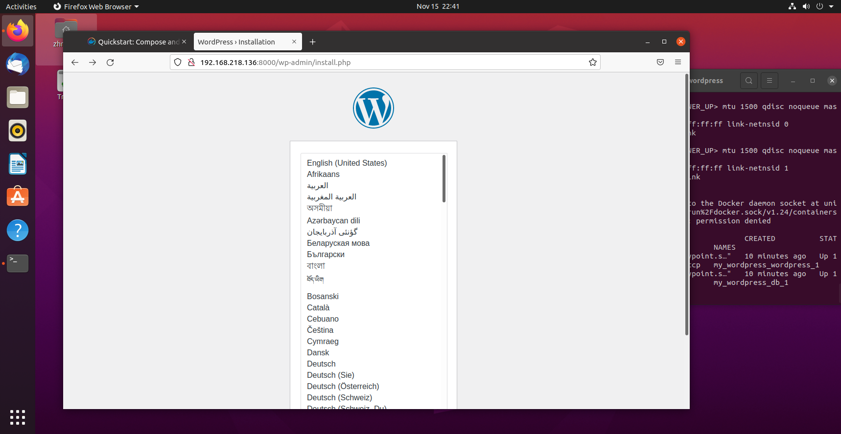

#After type your information and password. You will direct to login page.

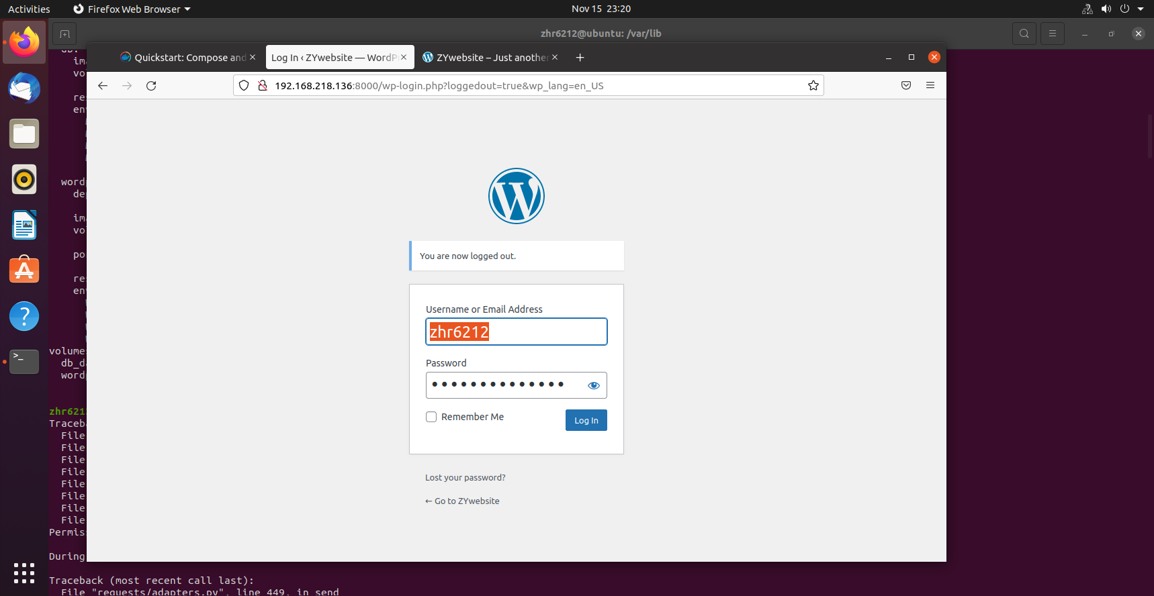

#Use the password you set and log in to the main page.

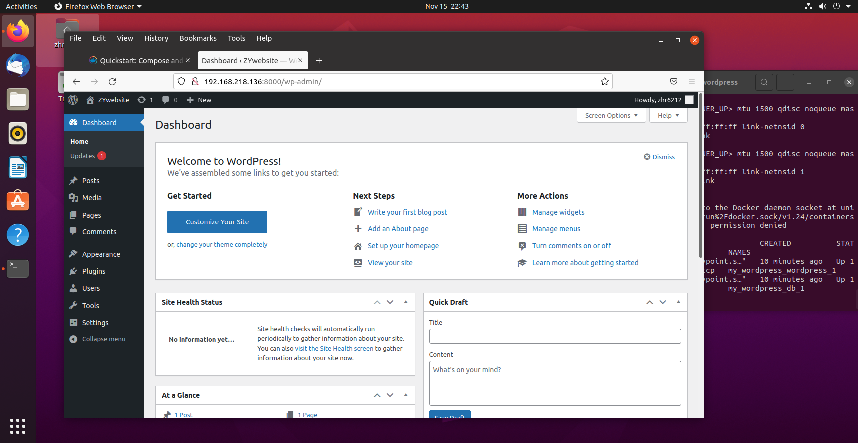

#Write the first blog and published it.

